Birla Institute of Technology & Science, Pilani
Work Integrated Learning Programmes Division
Second Semester 2023-2024

Mid-Semester Test
(EC-2 Makeup – ANSWER KEY)

Course No. : DSECL ZC556
Course Title : Stream Processing and Analytics
Nature of Exam : Open Book
Weightage : 30%
No. of Pages = 4

No. of Questions = 5
Duration : 2 Hours
Date of Exam : 06/03/2021 or 19/03/2021 (FN/AN)
Note to Students:
- Please follow all the Instructions to Candidates given on the cover page of the answer book.
- All parts of a question should be answered consecutively. Each answer should start from a fresh page.
- Assumptions made if any, should be stated clearly at the beginning of your answer.

Q1 Consider an Apache Zookeeper with different number of servers is set up. Discuss the consequences (if any) briefly, for each of the following server configuration in ensemble. [1 + 1 + 1 = 3]
- Single server
- Two servers
- Odd number of servers (more than one)
Answer:
- Single server – single point of failure
- Two servers – fault tolerance provided against failures but getting consensus while maintaining the state will be difficult as both of them has to agree for the same
- Odd number of servers – more fault tolerance and getting consensus will be easy as quorum will be easily obtained with odd number, but increasing the number of servers will have adverse impact on the performance
Q2. Imagine that you are building a next-generation telecom company, one that help users to avoid wastage of data from their existing data package subscription. First step is to deploy smart agent at customers’ phone. These agents will report the application data use of the phone every hour, along with information on which applications are consuming the more data. Based on this, we would like to offer customers variable pricing in real time, based on when and how they run their favorite applications. [1 + 2 + 1 + 1 + 1 = 6]
- Show a sample of the tuple generated out of the agent on phone.
- Give two examples of exploratory analysis you will do on this data? Give details.
- What can be the target variable in this example?
- What sort of data modelling technique can be utilized for it?
- Which type of system architecture will be useful in this scenario?
Answer:
- {Timestamp, phone_no, {app1:data_usage, app2:data_usage, app3:data_usage,…}}
- Each applications hourly / daily / day wise (week-day/week-end) data usage
Day wise data requirements for a device
Categorizing the data usages by types of applications – entertainment, work related
- Recommended plan or subscription value
- Classification – for plan recommendation , Regression – for plan value
- Lambda – Both current and historical data taken into consideration for plan recommendation

Q.3 A streaming data application is built to process the events received from different data sources. This processed data needs to be made available to various clients for further usage. This data should be available for six months after it’s processed. The process of storing the data should not cause any impact for the analysis layer. The data persistence can be handled in the batch manner. Propose a suitable storage solution that will help to meet the all above mentioned requirements for data storage. [6]
Answer:
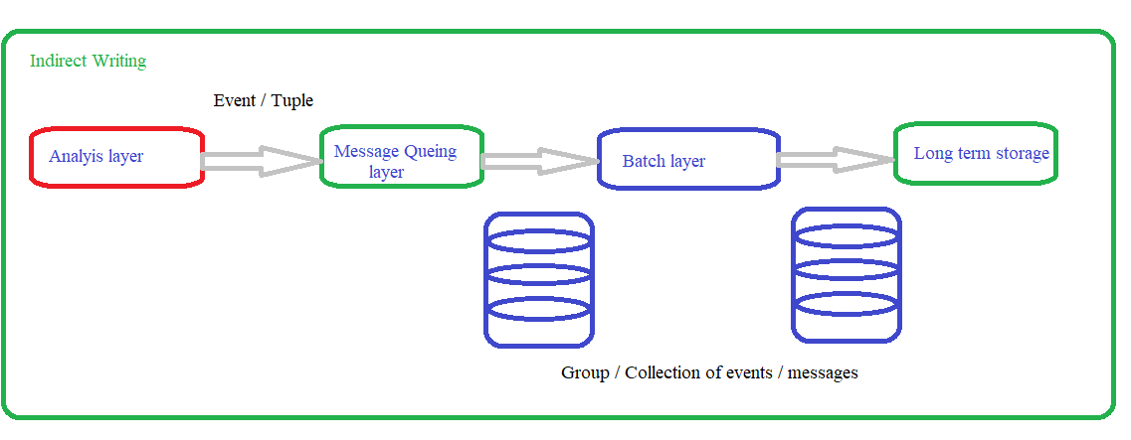
Identifying the long term storage mechanism – 1 mark
Decoupling between Analysis layer and Batch layer – 2 marks
Writing the messages between the batch layer and long term storage – 2 marks
Drawing the overall architecture diagram – 1 mark

Q4. Answer the following questions in brief: [2 *3 = 6]

- Why messaging or data flow layer is required in streaming data systems?
Answer:
To provide the required delivery semantics like at-least-once in the streaming data systems
To prevent the processing layer from huge processing backlog
- List four common data processing operations that can be performed on the streaming data.
Answer:
- Cleaning
- Filter
- Join
- Grouping

- List down two points which motivates the need of systems like Apache Zookeeper in distributed environments?
Answer:
Managing the metadata of the cluster
Maintaining the distributed state of the cluster

Q5. Consider the following Kafka Cluster description. [3 + 1 + 1 + 1 = 6]
- 4 node cluster
- Name of the Topic: Bus
- Number of Partitions: 3
- The Replication factor of ‘Bus: 2
- 3 producers
- 2 consumers
- Draw Kafka’s architecture clearly highlighting the following in a block diagram
-producers, consumers, broker, topic and partitions.
Answer:
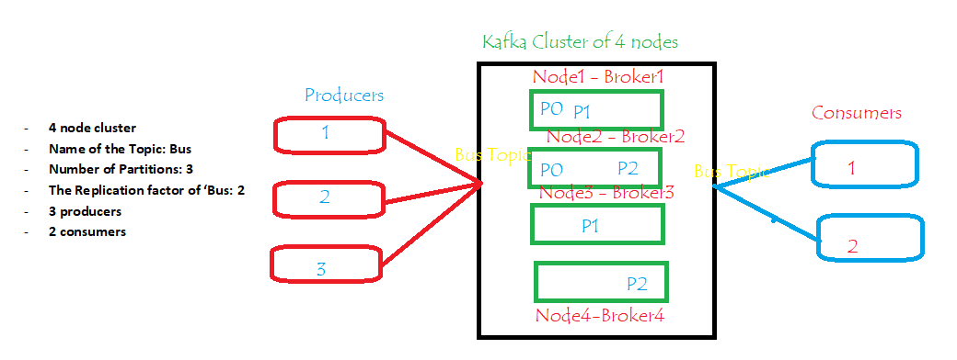
Producers = 0.5
Consumers = 0.5
Borker = 1
Topic , partition , replica = 1

- How many consumer groups can be created for this configuration?
Answer:
There can be an indefinite number of consumer groups working simultaneously.

- What is the maximum number of consumers that each consumer group can have while ensuring maximum parallelism?
Answer:
3 – Each reading from a different partition

- What is the maximum number of server failures that this setup can handle?
Answer:
3

Q6. Consider the use case of real time traffic and routing service for the vehicles on the road. The traffic and navigation service is expected to handle requests from lot of cars. [1+1+1=3]
a) What will be the appropriate interaction pattern in the collection tier?
b) Suggest message delivery semantics for this problem.
c) List out storage requirements with respect to analytics tier.

Answer:
a) The suitable interaction pattern in this case would be -request response pattern because the navigation service can handle the requests pertaining to the the traffic and alternate routes for the cars simultaneously because in this usecase ability to asynchronously request data and process the data as it arrives will be critical.
b) Message delivery semantics is atmost once because:
In case communication between the collection tier and analysis tier is interrupted for a longer time, there could be delay of service to the vehicle drivers and there is no life risk when system fails (low tolerance). Also it might require small chunk of data storage daily basis. The locality specific data is only under consideration
c) Storage Solution: data can be stored and refreshed in periodic intervals of time. Hence message queues would suffice instead of long term storage for further analysis. Analysis on congested areas, locations and time stamps can be used to develop predictive models for later use for which recent past data would be sufficient.

********************

